**Shoulder pain**

**Initial Assessment**

|  |  |  |
| --- | --- | --- |
| **Presenting Symptom/Chief Complaint** | | |
| Patient is complaining of both shoulder pain with stiffness at the upper back and neck area due to a lot of stress. | | |
| **Main Signs and Symptoms** | | |
| Patient has a poor sleep, overeating and a lot of stress at work and daily living condition. | | |
| **Other Signs and Symptoms** | | |
| Poor sleep, low energy level. Overwhelming and a lot of stress. | | |
| **TCM Diagnosis and Treatment (identified TCM disease, TCM differentiation of syndromes)** | | |
| Obstruction painful shoulder and upper back syndrome due to cold and wind, QI stagnation with overwork and stress. | | |
| **Treatment Principles and Strategies** | | |
| Remove the wind and cold. Nourish Qi level, stimulate the Qi and blood movement. | | |
| **Treatment Plan (Modalities; acupuncture, herbal, dietary, manual therapies), frequency and duration** | | |
| Acupuncture with distal points, sedation and local tonification and stress reducing protocol. Calming wind and stimulate the blood and QI circulation 1 hour 2 times a week. | | |
| **Any other Advice Given to Patients** | | |
| Acupuncture: Du 20; Du 14; UB 20; UB 11; GB 21; GB 20; SI 10, SI 11, SI 13, SI 14, LI 4; Lu 7; Lu 9; H7; H9; P6; P9 with tonification for 1 hour. St36, Sp6 - UB 60, UB 62, St 43, St 44 tonification. SI3 - sedation strong with following tonification at the beginning of the treatment. Removing the needles with expiration. Acupuncture with Moxibition and with light shoulder rotation. | | |
| **Practitioner:** | **Date:** | **Signature:** |

**Shoulder pain**

**Daily Charting____________________________________Patient Name: Rakhman Edward**

**Date:**

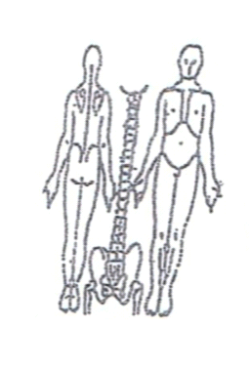**Working Diagnosis:** Obstruction painful shoulder syndrome with cold and wind invasion. Qi stagnation in the area due to stress.

S: Patient complaining to the lots of stress at work and daily living pain and strong

muscle spasm at the upper back and shoulders area.

O:

**Treatment (P)** Acupuncture: Du 20; Du 14; UB 20; UB 11; GB 21; GB 20; SI 10, SI 11, SI 13, SI 14, LI 4; Lu 7; Lu 9; H7; H9; P6; P9 with tonification for 1 hour. St36, Sp6 - UB 60, UB 62, St 43, St 44 tonification. SI3 - sedation strong with following tonification at the beginning of the treatment. Removing the needles with expiration. Acupuncture with Moxibition and with light shoulder rotation.

(A) Acupuncture 1 hour due to protocol

**Date:**

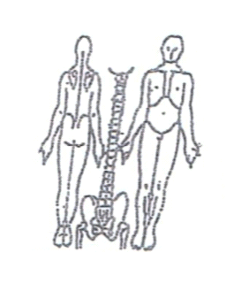**Working Diagnosis:**

S: Patient still has spasm and painful muscle contraction at the upper back and shoulders area. Sleeping much better, level of energy rising, feeling more energized during the day.

O:

Treatment (P) Acupuncture with Moxibition 1 hour.

(A)

**Date:**

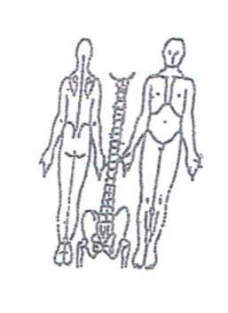**Working Diagnosis:**

S: Patient feeling better. N sleep and feeling recharging at the morning. Still have stiffness at the upper back. Pain especially during the day. N appetite, mood.

O:

Treatment (P) Acupuncture with Moxa 1 hour according to the protocol.

(A)

**Date:**

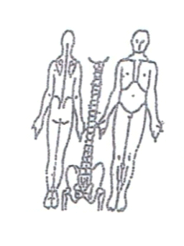**Working Diagnosis:**

S: Sleeping N; N level of energy. stress, mood. daily activity. level of energy at the end of the day.

O:

Treatment (P) Acupuncture with warm needles tonification of local points for 1 hour.

(A)

**Date:**

**Working Diagnosis:**

S: NO pain, feeling a lot of stress reduction, mood and motivation. N ROM, NO pain at the evening.

O:

Treatment (P) Acupuncture with light shoulder rotation for 1 hour.

(A)